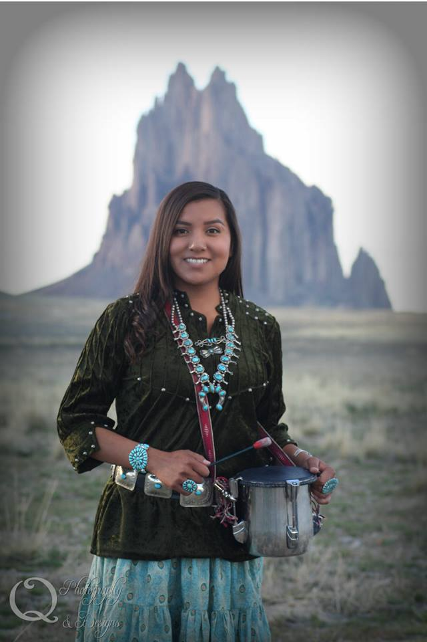

Native American Recording Artist * Motivational Speaker * Youth Advocate * Parent Advocate * Facilitator

Talibah Begay

**Address**: P.O Box 2832 Shiprock, N.M 87420

**Email**: [talibah_begay@yahoo.com](mailto:talibah_begay@yahoo.com)

**Phone**: (505) 436- 4122

 

Talibah Begay

Native American Recording Artist * Motivational Speaker * Youth Advocate * Parent Advocate * Facilitator

Topics:

-Traditional Singing

- Contemporary Singing

- Story Telling

- Navajo Shoe Game

- Navajo Stick Game

- Navajo Two Step & Skip Dancing (Audience Participation)

- Higher Education (Importance of education and attendance)

- Teen Dating / Teen Pregnancy / Teen Parenting

- Self-Identity

- Healthy Lifestyle

- Family Values

- Balancing Traditional & Western Worlds

- Traditional Teaching & Values

- Parenting / Single Parenting

- Suicide Prevention

- Drug & Alcohol Awareness

- Setting & Achieving Goals

- Self Confidence

- Teamwork

***Presenter Bio:***

Talibah Begay full Dine’ (Navajo), comes from a small town near the Four Corners called Shiprock, NM within the great Navajo Nation. She is the Red Cheek Clan, Born for the Towering House clan, her Maternal Grandparents are the Red Running into the Water clan, and her Paternal Grandparents are the Mexican People Clan. 24 years old, she is a single independent mother to a beautiful daughter. Talibah, has attended Navajo Technical University in 2010, and in 2011 attended Dine College, Currently attending Dine College majoring in Psychology, Minor in Dine Studies. In 2015- 2016 School year, Talibah was a former Culture teacher at Dream Dine Charter School located in Shiprock, NM. She worked with Kindergarten, First Grade and Second Grade Students.

At the age of 13 years old Talibah released her first album titled “Talibah’s Traditional Songs”, at the age of 14 years old she released her second album titled “Talibah Salute the Veterans” and at the age of 16 years old she released her third album titled “Navajo Songs for the Children”. Talibahs first album was nominated in two categories of “Best Female” and “Best Traditional” in the NAMMY’s (Native American Music Awards) held in Niagara Falls, NY in 2005. Talibah was raised with the value of the Navajo culture, attending various ceremonies with both her maternal and paternal grandparents, with the values and teachings instilled in her she promotes her cultural background.

*Through Music I have found the balance in my traditional upbringing and living in a western society, I truly believe music brings emotions into one’s mind, music teaches and heals*.

***Presentation Durations:***

Speaking or Singing Engagement: 30min-45min

Speaking Engagement and Singing: 45min- 1hr

Speaking/Singing/Audience Participation: 1hr- 1hr and 30mins

***Booking Quote:***

$800 + Travel Expense (Mileage)

(**May come into effect if needed**) 1 or 2- night hotel stay depending on distance and time of presentation)

*Now Accepting Credit Card Payment*

**\*Plus Tax**

***Talibah will Educate, Entertain, and Inspire through music, speaking and audience participation/Interaction.***

